ROS

Commands

- source /opt/ros/noetic/setup.bash
- catkin_make
- catkin_make -DPYTHON_EXECUTABLE=/usr/bin/python3 permission denied solution:
- source devel/setup.bash
- . ~/catkin_ws/devel/setup.bash
- roscd beginner_tutorials
- chmod +x listener.py

- roscore
- roscd ros_pub_and_sub_rgbd_and_cloud
- rospack depends beginner_tutorials
- rosrun beginner_tutorials publisher.py

- rosrun tf static_transform_publisher 0 0 0 0 0 0 1 map base 10
- rosrun rviz rviz
- rostopic list
- rostopic echo /test_data/width ------> for listening the published data
- rostopic echo -n1 /camera/depth_registered/points
- rostopic info /camera/depth_registered/points
- rostopic echo /camera/depth_registered/points | grep 2022-07-21-15-39-00.bag
- rosrun ros_pub_and_sub_rgbd_and_cloud pub_rgbd_and_cloud.py

# Usage instructions

(0) Check configurations in [config/rgbd_pub_config.yaml](config/rgbd_pub_config.yaml).
Make ROS nodes executable:
``` bash
chmod a+x pub_rgbd_and_cloud.py
chmod a+x sub_rgbd_and_cloud.py
roscore # Start ROS.
```

(1) Set camera pose (Not necessary):
``` bash
$ rosrun tf static_transform_publisher 0 0 0 0 0 0 1 map head_camera 10
```
This step is just for visualization in rviz. The camera's frame_id `head_camera` is set in the config file.

(2) Publish data:
``` bash
$ rosrun ros_pub_and_sub_rgbd_and_cloud pub_rgbd_and_cloud.py \
--base_dir $(rospack find ros_pub_and_sub_rgbd_and_cloud) \
--config_file config/rgbd_pub_config.yaml
```

(3) View result in RVIZ:
(If you change the topic names in config file, you also need to change it in rviz.)
``` bash
$ roslaunch ros_pub_and_sub_rgbd_and_cloud run_rviz.launch
```

(4) Run steps (1)~(3) by using `roslaunch` (You need stop the above 3 commands first):
``` bash
$ roslaunch ros_pub_and_sub_rgbd_and_cloud run_publisher.launch
```

(5) Subscribe data:
``` bash
$ rosrun ros_pub_and_sub_rgbd_and_cloud sub_rgbd_and_cloud.py \
--base_dir $(rospack find ros_pub_and_sub_rgbd_and_cloud) \
--config_file config/rgbd_pub_config.yaml
```

RVIZ static transform visuals:
rosrun tf static_transform_publisher 0 0 0 0 0 0 1 map head_camera 10
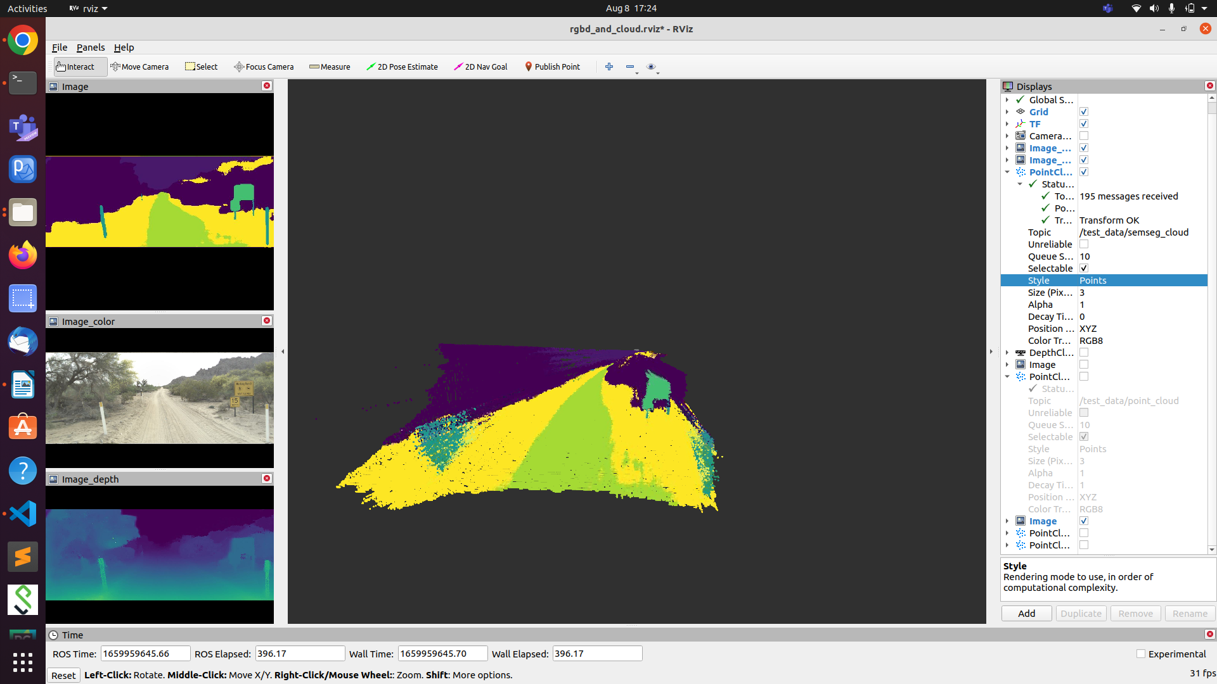
rosrun tf static_transform_publisher 0 0 0 0 0 1 0 map head_camera 10
---- inverted image
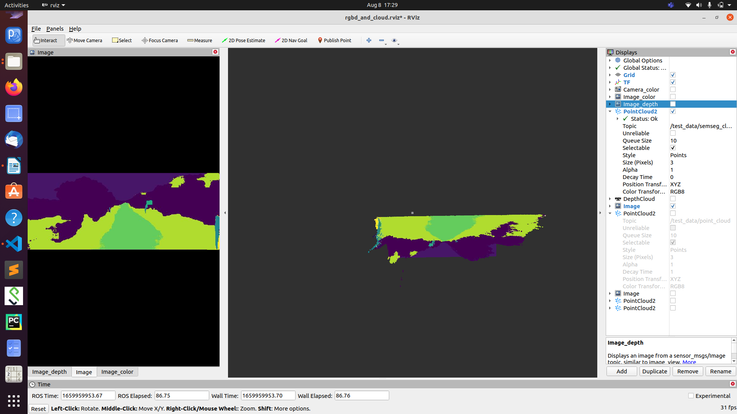
rosrun tf static_transform_publisher 0 0 0 0 1 0 0 map head_camera 10
( left become right and right becomes left)- like a mirror image
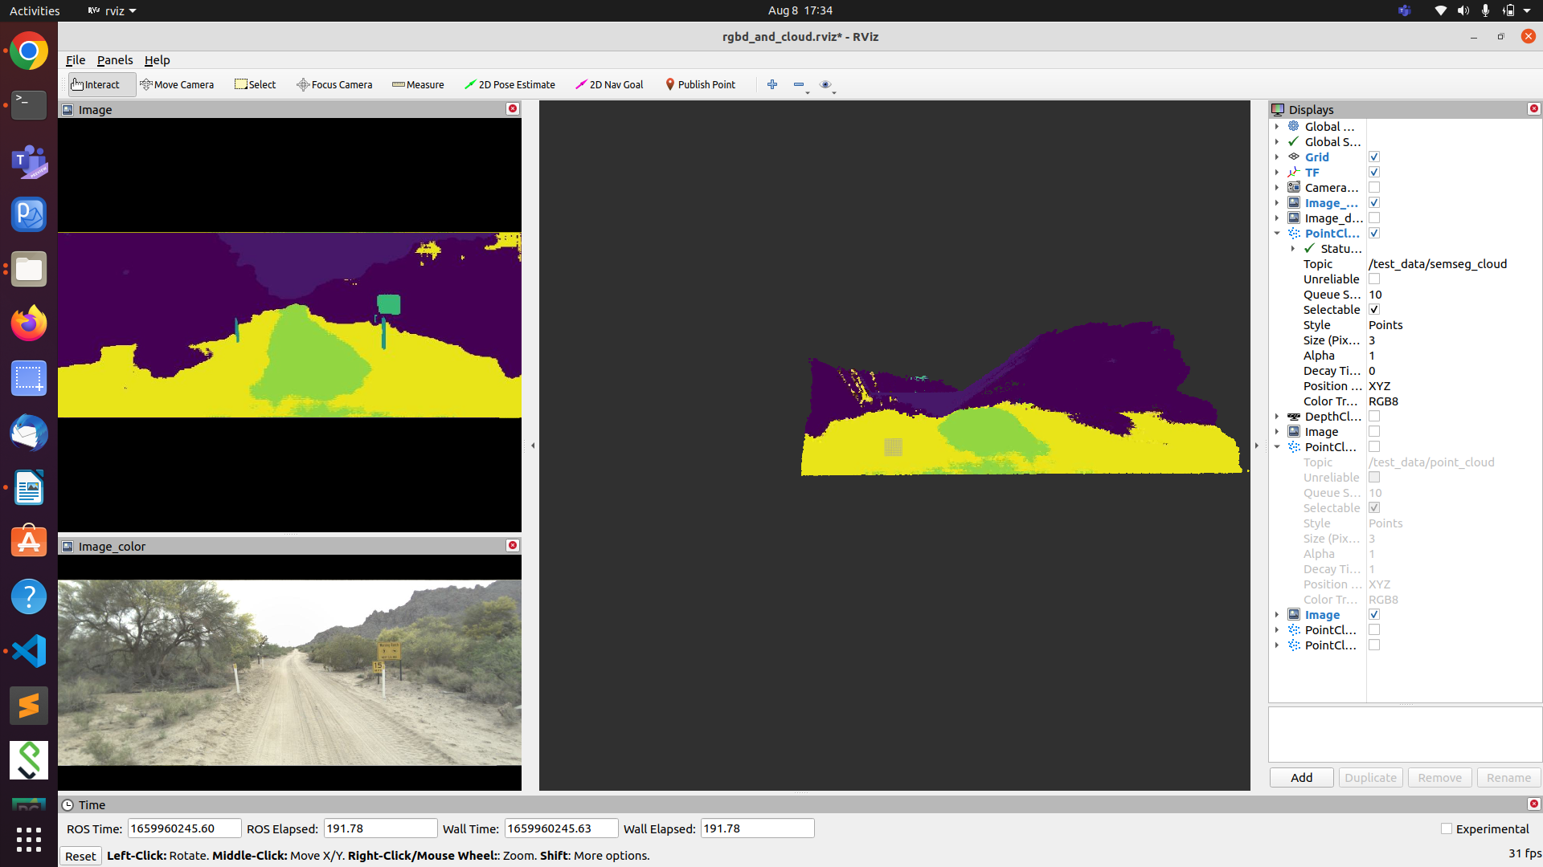

rosrun tf static_transform_publisher 0 0 0 0 1 0 0 map head_camera 10
(inverted like a water image- up <-> down, right <-> left )
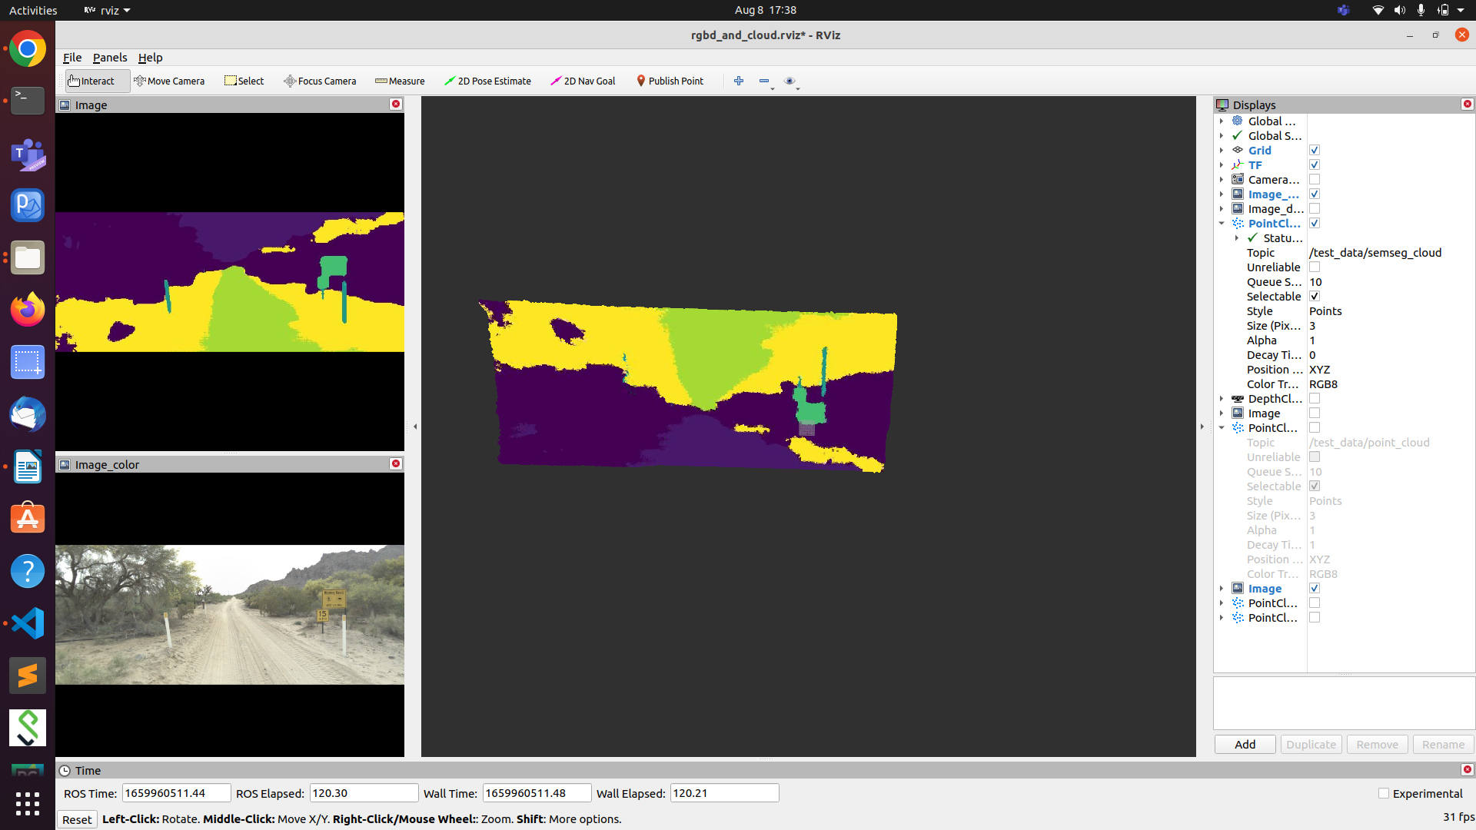
rosrun tf static_transform_publisher 0 0 0 1 1 0 0 map head_camera 10
(horizontal to vertical) and left-> right
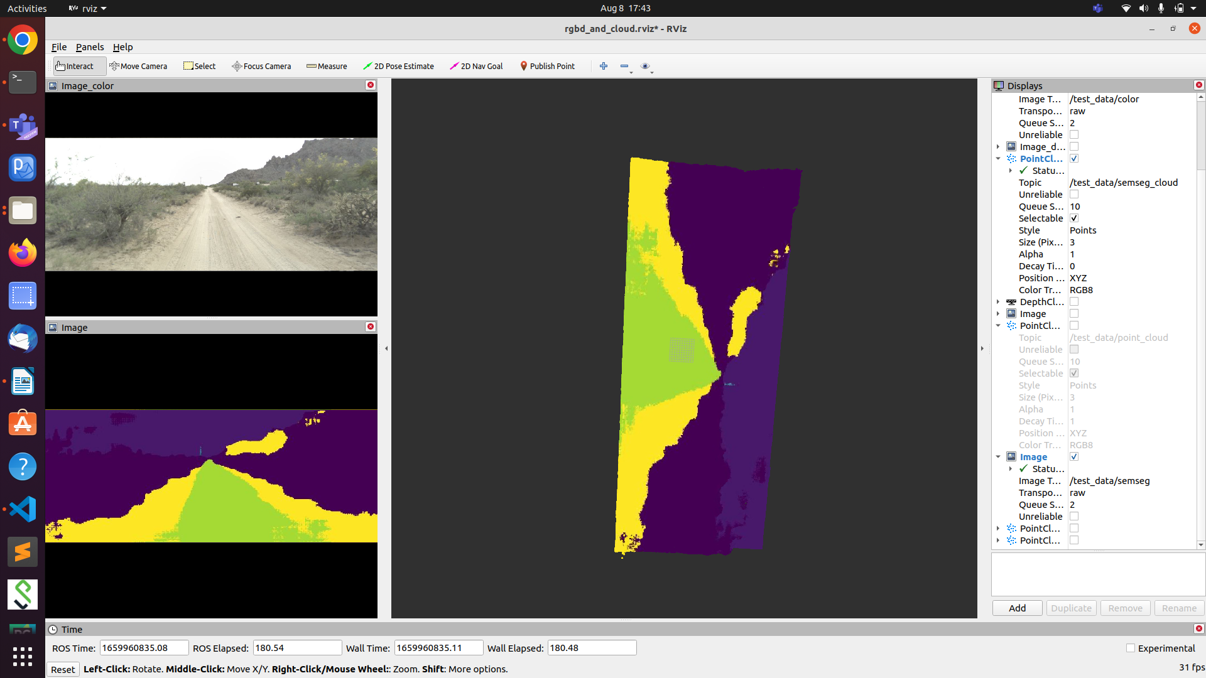
rosrun tf static_transform_publisher 0 0 0 0 0 1 1 map head_camera 10
horizontal -> vertical but left and right not changed

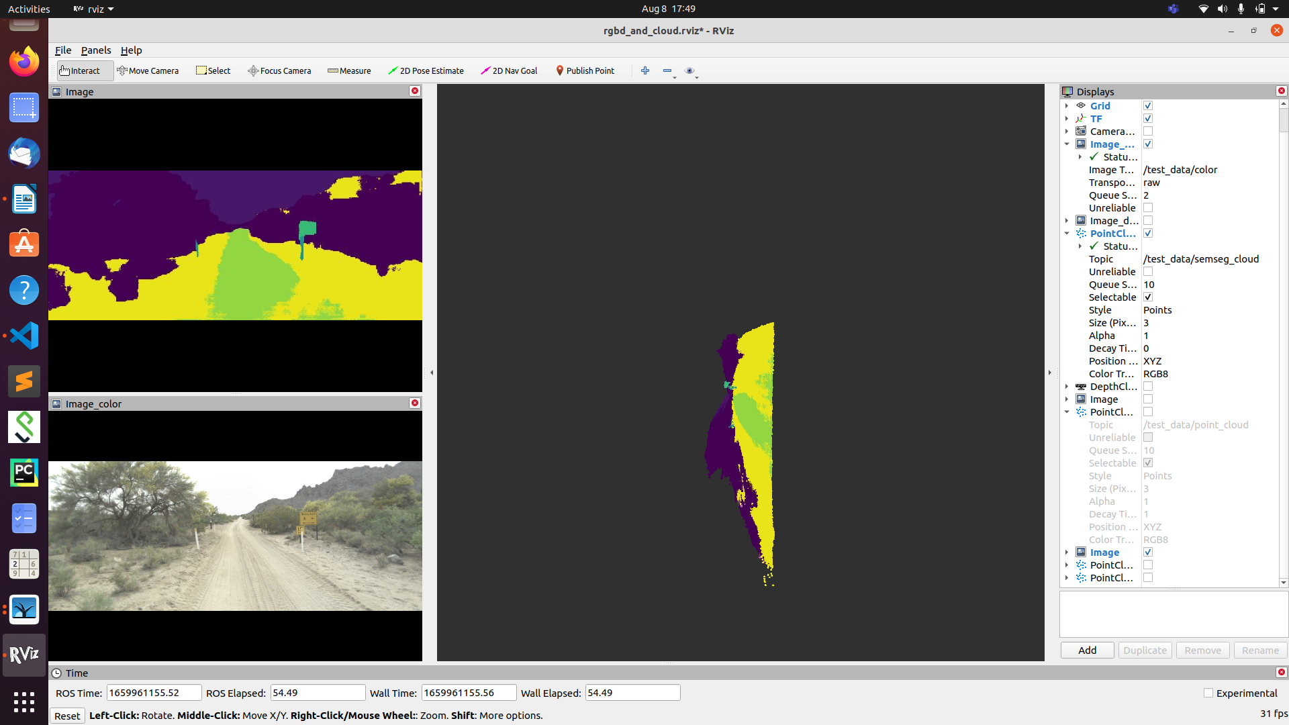
rosrun tf static_transform_publisher 0 0 0 0 1 1 1 map head_camera 10
corner view may be

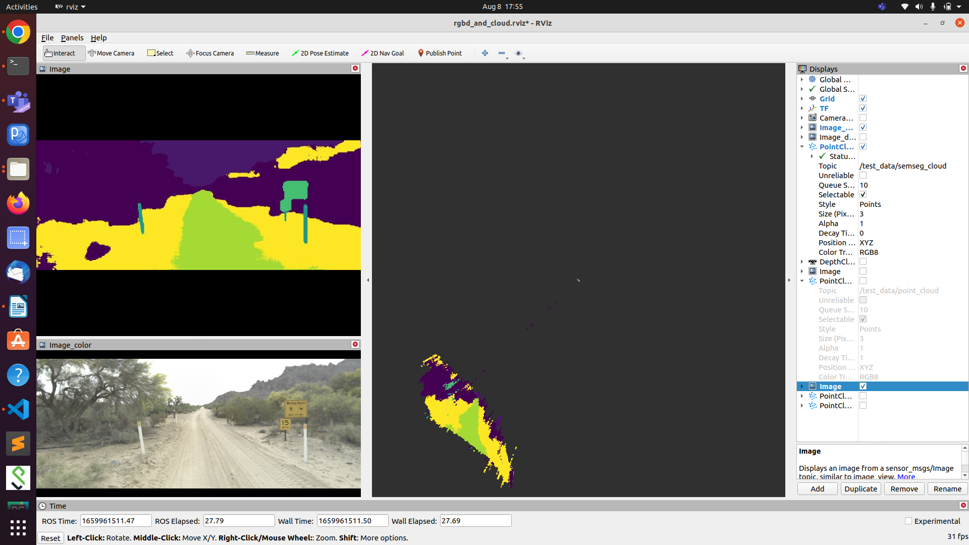

Example 1

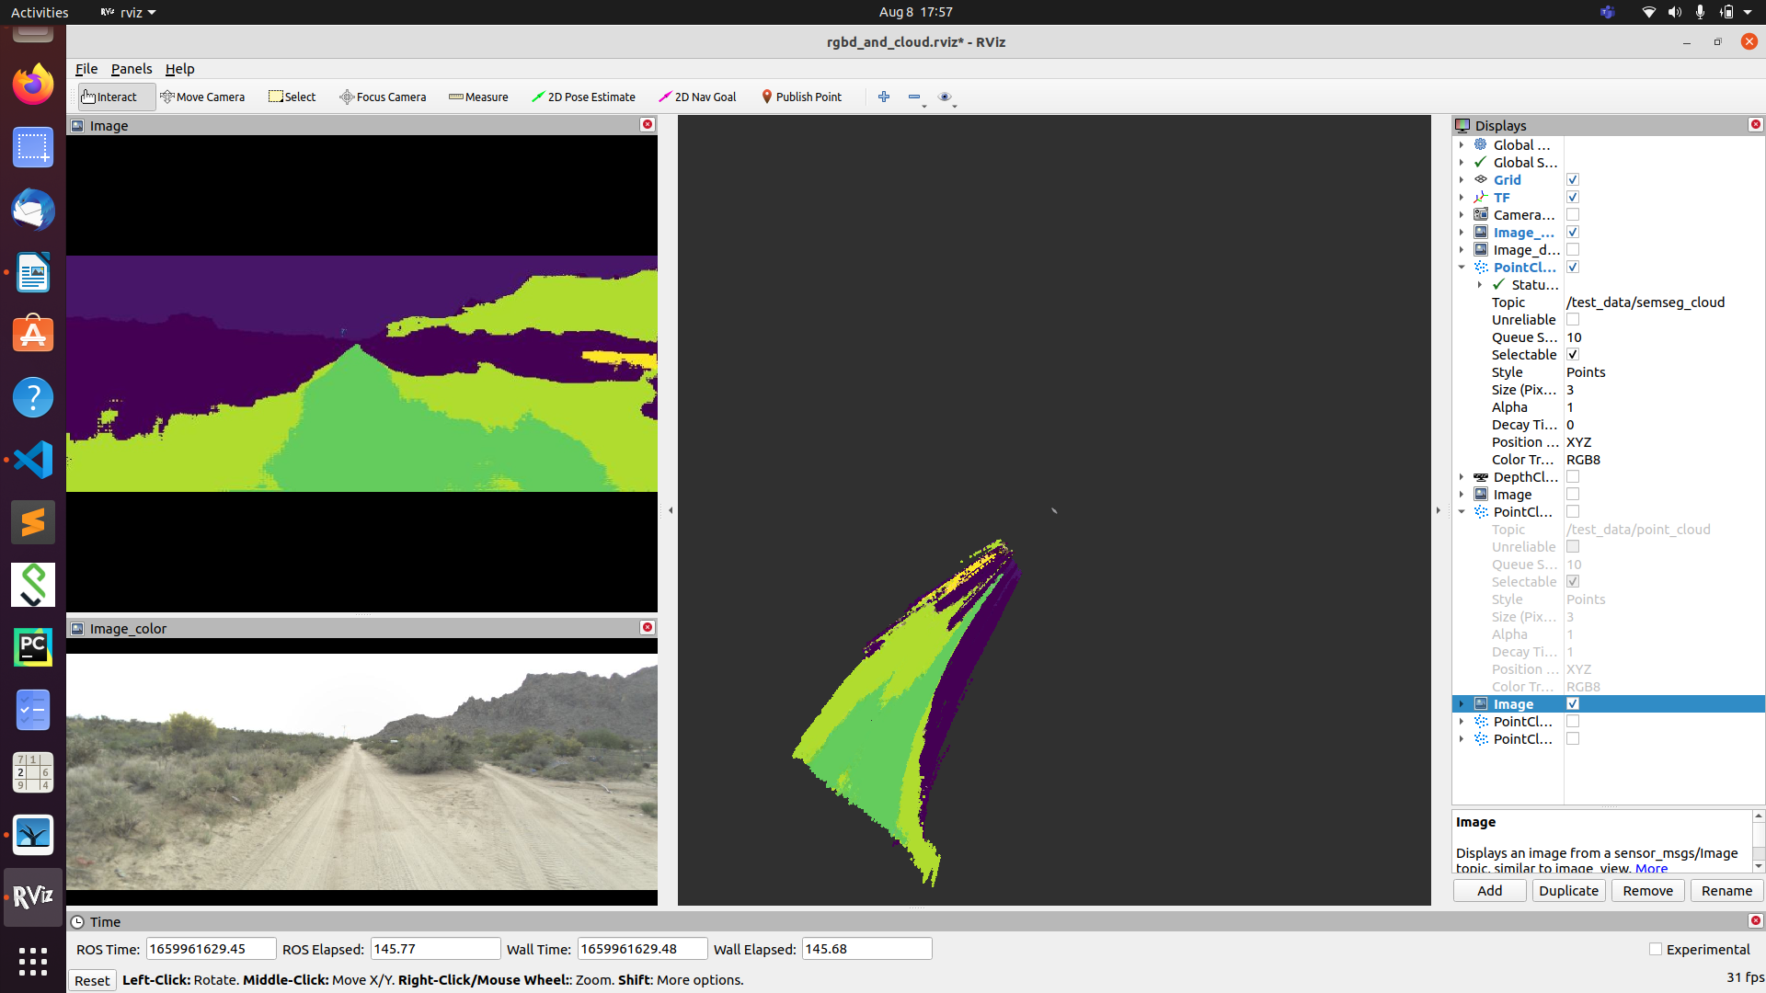
Example:2

rosrun tf static_transform_publisher 0 0 0 1 1 1 1 map head_camera 10
Side view may be

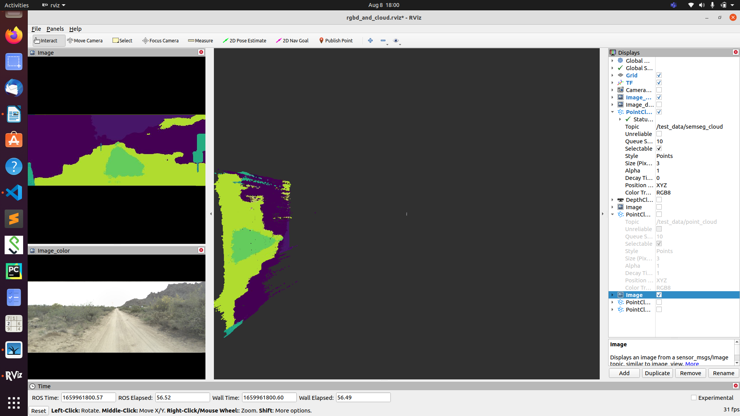

rosrun tf static_transform_publisher 0 0 0 1 0 0 1 map head_camera 10
front view reversed may be (don’w know exactly)

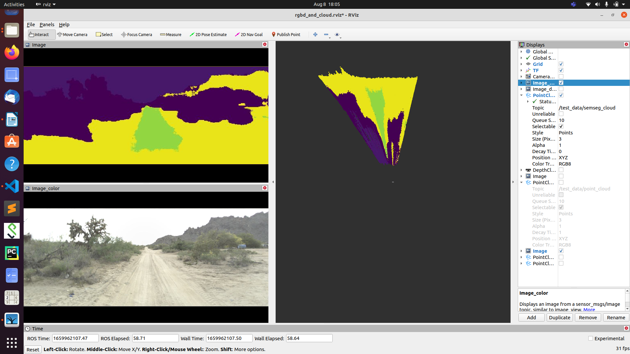

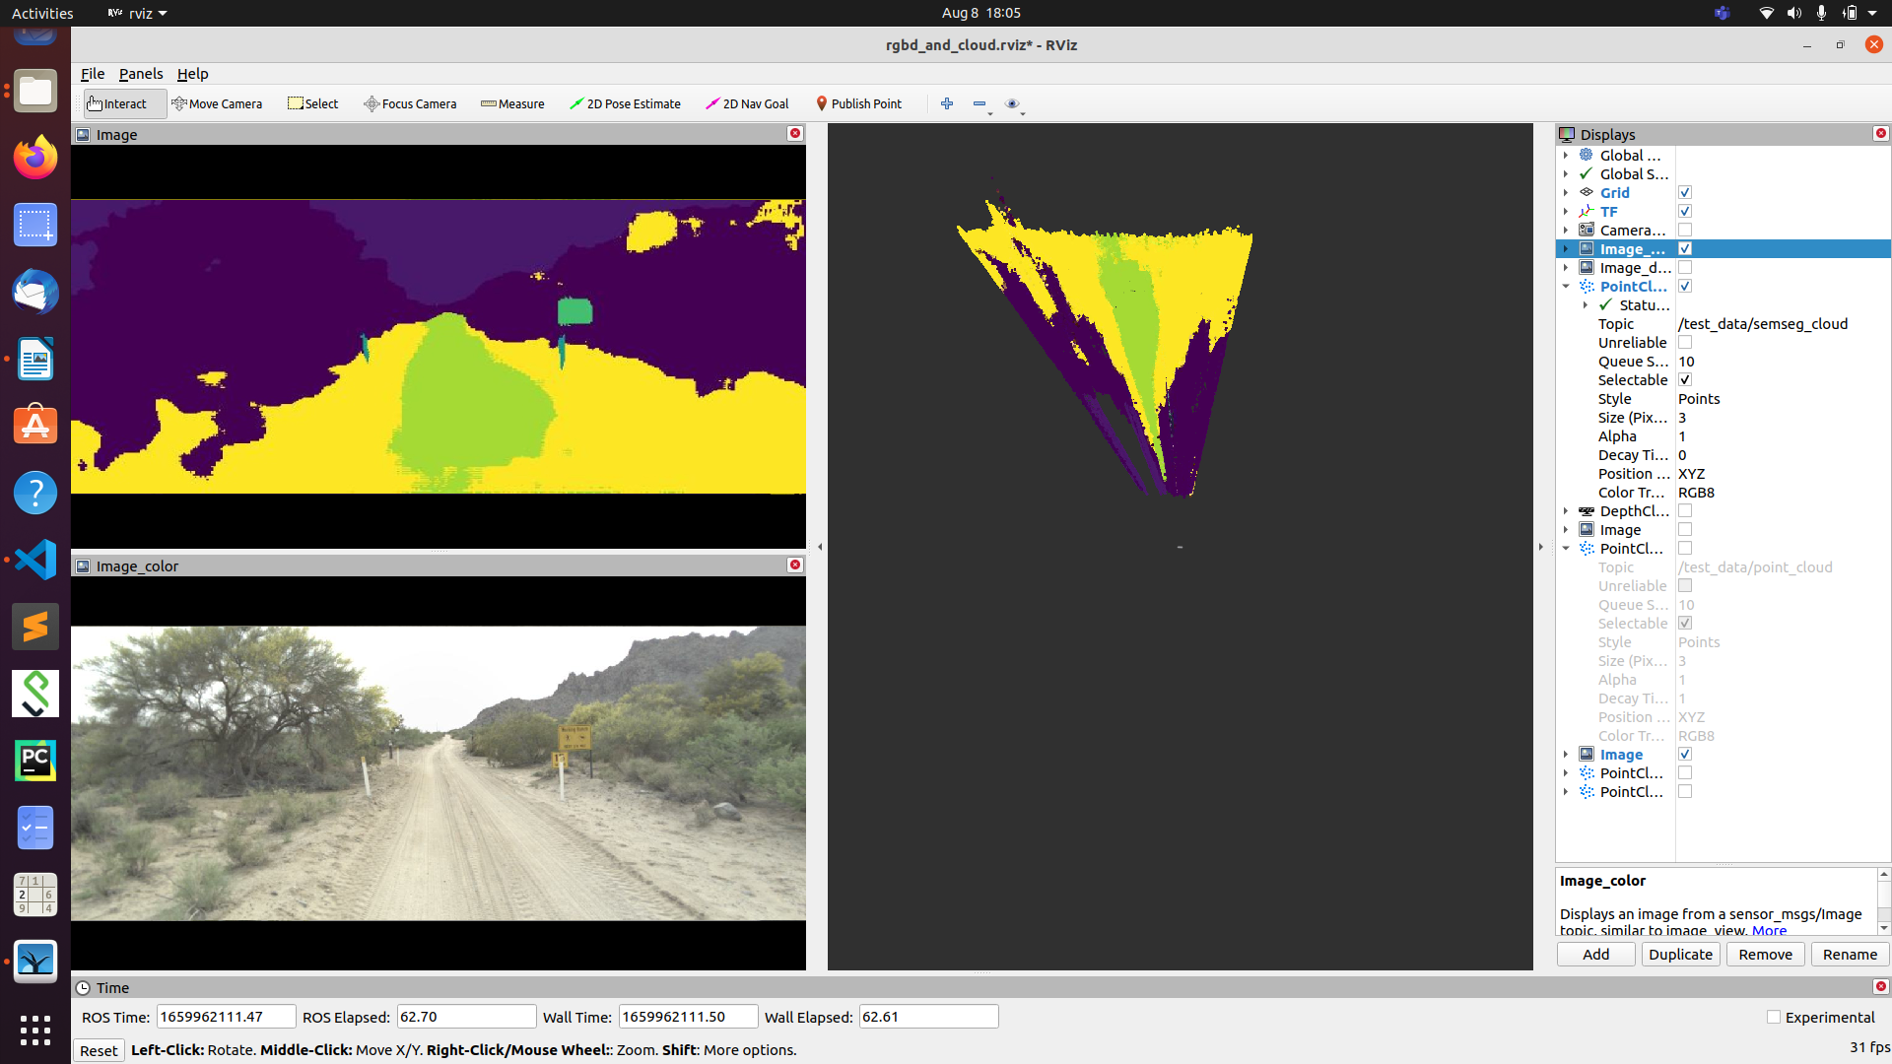

osrun tf static_transform_publisher 0 0 0 1 0 1 1 map head_camera 10
corner view reversed may be (don’t know exactly)
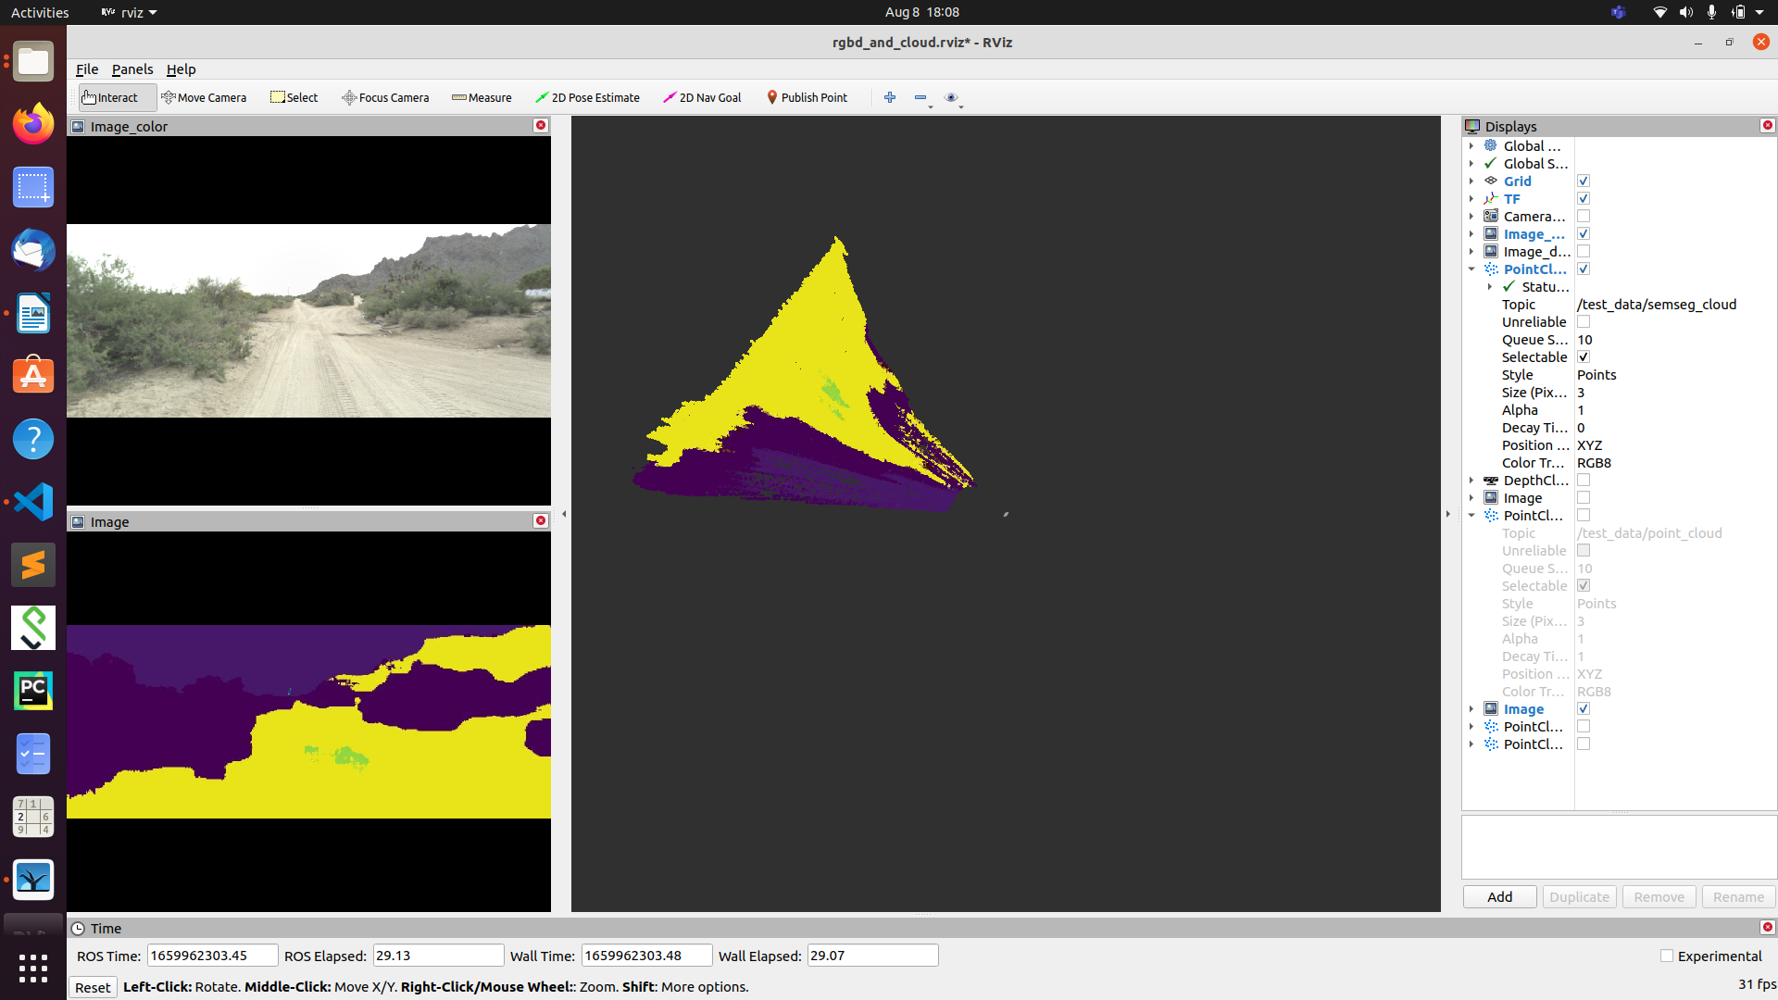

Note:
These will depends on the previous view of the point cloud.

rosrun tf static_transform_publisher 0 0 0 1 1 0 1 map head_camera 10
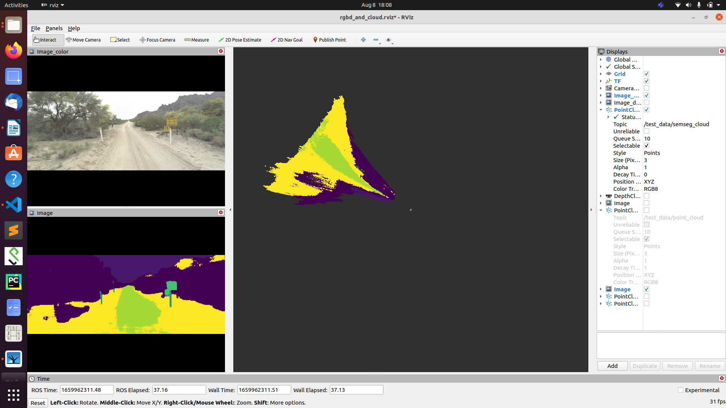

Both Semseg and RGB pointcloud in RVIZ

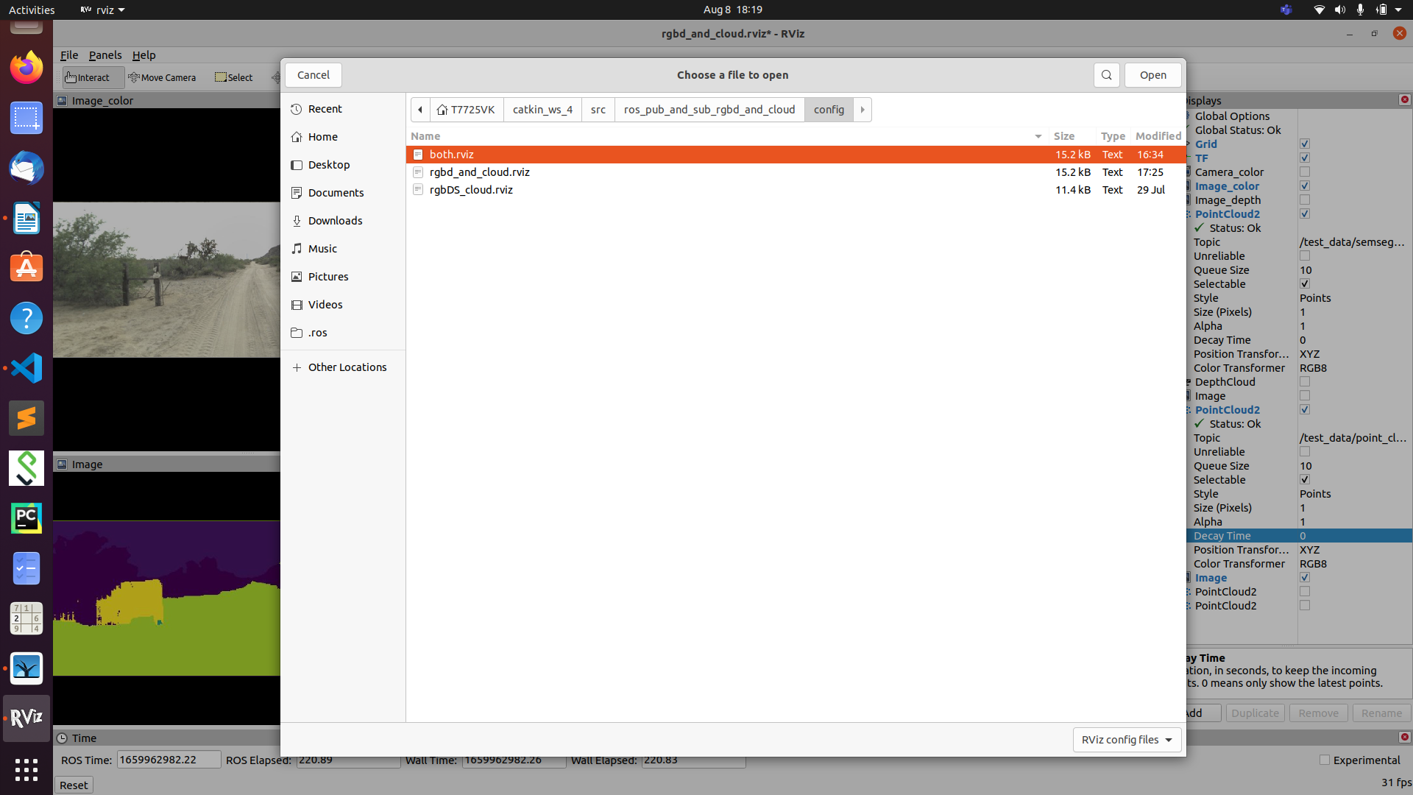

If we change the decay time, in both point_cloud and sem_seg_cloud, we can visualize both the point clouds.

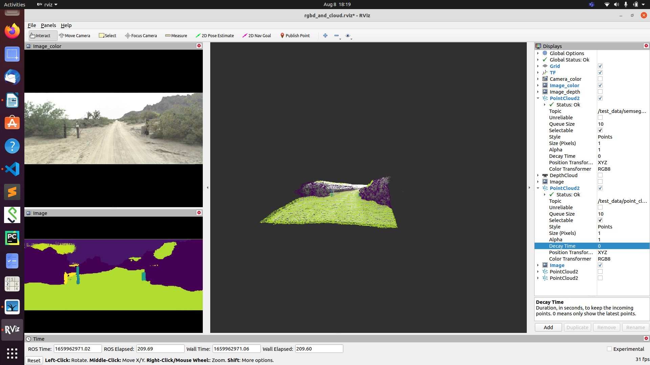

Note:
These will depends on the previous view of the point cloud.

ROS bag visualise:
- rosbag record camera/depth_registered/points
- rqt_bag
- rosbag play --clock '2022-07-21-15-20-52.bag'
Create package:
catkin_create_pkg learning_tf2 tf2 tf2_ros roscpp rospy turtlesim

Create Workspace:

$ mkdir -p ~/catkin_ws/src
$ cd ~/catkin_ws/
$ catkin_make
- catkin_make -DPYTHON_EXECUTABLE=/usr/bin/python3
- source devel/setup.bash

Install ROS tutorial:
sudo apt-get install ros-<distro>-ros-tutorials

change directory in ROS:

roscd roscpp

Make Executable:
- chmod +x listener.py
Check dependencies in ROS package

- rospack depends beginner_tutorials
create a launch file:

Create a folder called ‘launch’.
mkdir launch
Create a new launch file inside the launch directory you just made.
cd launch
Open up the text editor.
gedit

Type the code below into the file, and save it. I’m going to save mine as talker_listener.launch. Save this file to the catkin_ws/src/hello_world/launch folder. This file will run C++ executables.
1  2  3  4 | <launch>  <node name="listener_node" pkg="hello_world" type="listener" output="screen"/>  <node name="talker_node" pkg="hello_world" type="talker" output="screen"/>  </launch>

Note in the code above, if we are running a Python script, you will put the name of the script between the double quotes after type=. For example, if we want the launch file to run code named example.py, that line of the launch file code would look like this:
<node name="listener_node" pkg="hello_world" type="example.py" output="screen"></node>
chmod +x example.py

Change the permissions of the launch file we just created. It will ask you for your password.
sudo chmod +x talker_listener.launch
Run the launch file. Note that roslaunch automatically starts up roscore, so you don’t need to type roscore.
roslaunch hello_world talker_listener.launch

run launch file:
roslaunch ros_pub_and_sub_rgbd_and_cloud run_rviz.launch

-------------------------------------------------------------------------------------------------------------------------------
ROS Taks-1

lib_commons.py ->

read_yaml_file , read_json_file, get_filenames (for image names)

lib_rgbd.py ->

* class MyCameraInfo
get_cam_params, to_open3d_format, (data)_from_ros_camera_info ,

* def create_open3d_point_cloud_from_rgbd(create_open3d_point_cloud_from_rgbd(
color_img, depth_img,
cam_info,
depth_unit=0.001,
depth_trunc=3.0):
)
create_open3dpoint_cloud_from_rgbd cloud of open3d format,
given opencv rgbd images and camera info.
Arguments:
color_img {np.ndarry, np.uint8}: 3 channels of BGR. Undistorted.
depth_img {np.ndarry, np.uint16}: Undistorted depth image that matches color_img.
cam_info {CameraInfo}
depth_unit {float}: if depth_img[i, j] is x, then the real depth is x*depth_unit meters.
depth_trunc {float}: Depth value larger than ${depth_trunc} meters gets truncated to 0.
Output:
open3d_point_cloud {open3d.geometry.PointCloud}
See: http://www.open3d.org/docs/release/python_api/open3d.geometry.PointCloud.html
Reference:

lib_ros_rgbd_pub_and_sub .py

-> ColorImagePublisher, DepthImagePublisher, CameraInfoPublisher

------------------------------
RGBD image publisher and subscriber.

Publisher:
class ColorImagePublisher, publish()
class DepthImagePublisher, publish()
class CameraInfoPublisher, publish()

Subscriber:
class ColorImageSubscriber, has_image() & get_image()
class DepthImageSubscriber, has_image() & get_image()
--------------------------------

create_header(frame_id) defination
class AbstractImagePublisher(object) #inderitance
to_ros_image(image)

class ColorImagePublisher(AbstractImagePublisher):

_to_ros_image(self, cv2_uint8_image, img_format="bgr")

class DepthImagePublisher(AbstractImagePublisher):
_to_ros_image(self, cv2_uint16_image)

class CameraInfoPublisher():
Publish image size and camera instrinsics to ROS CameraInfo topic. The distortion is not considered.

publish_open3d_format_intrinsics(self, open3d_camera_intrinsic, frame_id="head_camera")

publish_ros_format_camera_info(self, camera_info)
_2d_array_to_list(self, intrinsic_matrix)

class AbstractImageSubscriber(object) #inheritance #subscriber
get_image()
_convert_ros_image_to_desired_image_format(self, ros_image)

class ColorImageSubscriber(AbstractImageSubscriber)

_convert_ros_image_to_desired_image_format(self, ros_image)

class DepthImageSubscriber(AbstractImageSubscriber):

_convert_ros_image_to_desired_image_format(self, ros_image):

class CameraInfoSubscriber(object):

get_camera_info()

has_camera_info()

_callback()

4. lib_cloud_conversion_between_Open3D_and_ROS.py

This script contains 2 functions for converting cloud format between Open3D and ROS:
* convertCloudFromOpen3dToRos
* convertCloudFromRosToOpen3d
where the ROS format refers to "sensor_msgs/PointCloud2.msg" type.

This script also contains a test case, which does such a thing:
(1) Read a open3d_cloud from .pcd file by Open3D.
(2) Convert it to ros_cloud.
(3) Publish ros_cloud to topic.
(4) Subscribe the ros_cloud from the same topic.
(5) Convert ros_cloud back to open3d_cloud.
(6) Display it.
You can test this script's function by rosrun this script.

-----------------------------------

5. lib_ros_point_cloud_pub_and_sub.py

class PointCloudPublisher(object):

class PointCloudSubscriber(object)

pub_rgbd_and_cloud.py =

class RgbdDataLoader(object):Data loader for color, depth, camera_info, and point cloud

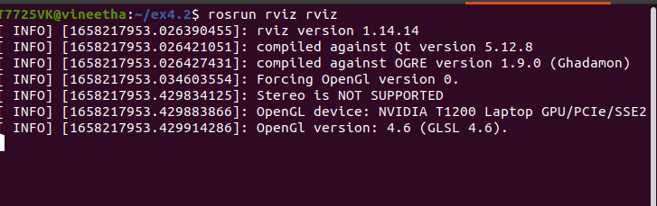

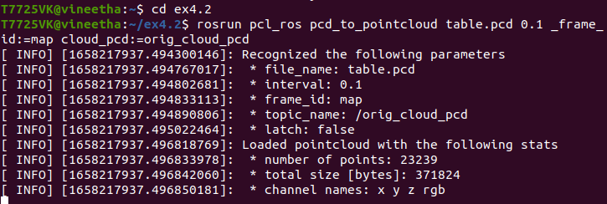

Remove Trash files from Trash:
cd .local/share/Trash

sudo rm -rf *

ROS for creating two weeled robot:
git clone https://github.com/PacktPublishing/Hands-On-ROS-for-Robotics-Programming

-------------------------
Scale the unit16 values with

